Ottershaw Park Estate
Map of Private Houses and Apartments

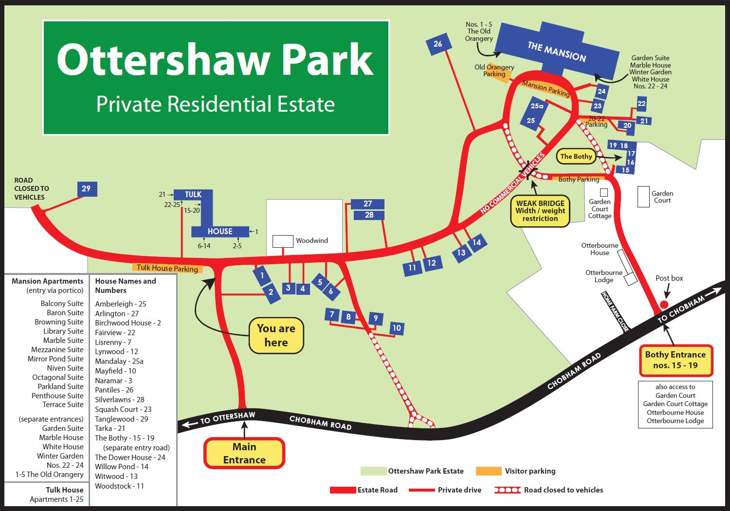

Reproduced by courtesy of Ottershaw Park Estate Company

