Ottershaw Park Mansion Newsletter

Edition 04 March 2023

A message from the Management Committee Chairman

Dear Fellow Residents,

I am delighted to be able to welcome you all to this edition of the Mansion Newsletter. In spite of the receding threat of Covid, we seem to have weathered the summer drought, the political turmoil and the loss of our monarch whose life and service was the subject of much celebration at The Mansion through the years – not least the latest Diamond Jubilee celebrations. Hopefully, we will have a Coronation Party this spring. It will give us a chance to celebrate the heritage which The Mansion reflects.
The resident community ebbs and flows and I would like to welcome David Moran and Sioban Hughes and Alex King to the Mansion community . I want to thank Harald Karlsen who served the community at the Management Committee and oversaw the important areas of fire safety and regulation.

We remain under pressure from the rising cost of living and, even though we are blessed with a solid group of residents who give so much time to managing Mansion affairs and saving a lot of otherwise external costs, we battle, along with the rest of the world, the inflationary impact of the global economic situation. Be rest assured that the Management Committee works very hard to provide excellent value for money, with superb help from non-residents such as Scott Carey; and will continue to do manage your service charges carefully and in the best interests of the community as a whole.

On the brighter side, we will be applying as much of your funds as we reasonably can to improving the Estate – both visible (gardens, leisure facilities) and invisible (building structure and integrity). We are all very proud of the environment in which we have the privilege to live and enjoy the tremendous amenity of the Surrey countryside, so effortlessly from our back doors. It is a unique environment, and a beautiful one, and although it comes at an increasing price, we should not forget how lucky we are to be guardians of this part of English history at a time when we are reflecting on the values which make being British so unique.
Russell Jacobs
The Garden Suite, No. 2
A warm welcome to new residents

We welcome David Moran and Siobhan Hughes (no known relation to Graham of that ilk.) (8 The Mansion, Octagonal Suite)
They look like:
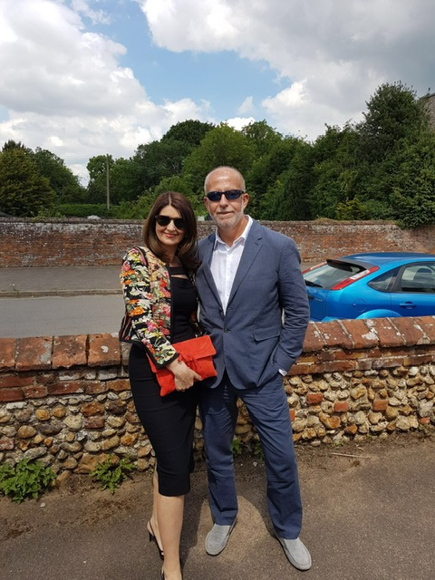

and we await a short bio for the next edition.

We also welcome Alex King (24 The Mansion)

He writes:

Hello all, there has been a very warm welcome since I have arrived and have met a few of the residents alone the way, I very much look forward to meeting you all over the coming months.
I’m currently making the most of some very valuable down time after a very hectic schedule, I have my own company that builds, modifies and prepares all kinds of vehicles for the film industry. I recently finished ‘Indiana Jones’ ‘Fast and Furious 10 ‘ most recently ‘Gran Tourismo’. Not sure what my next film project will be, so I guess I will just have to make the most of the facilities and relax.

I’m also about to launch a sustainability website for the media industry called Production Asset Listing www.pal.film this has been a seven year project and am about to launch and make the site transactional.
As you might have guessed I have quite a passion for cars and motorcycles, mostly vintage but some modern, its very exciting to learn that there are a few like minded people here, not to mention that the racing legend Tony Brooks once lived here too.
I’m very excited to be undertaking the task of making number 24 my own.
Have a fantastic year!

And looks like:

A friendly hello from other residents

We thought it would be a nice idea to continue to add a segment in which two or three residents briefly introduce themselves to the Mansion community, even if they have been here for some time!

Firstly Oliver and Kathy O’Callaghan-Brown (Terrace Suite – 4 The Mansion)
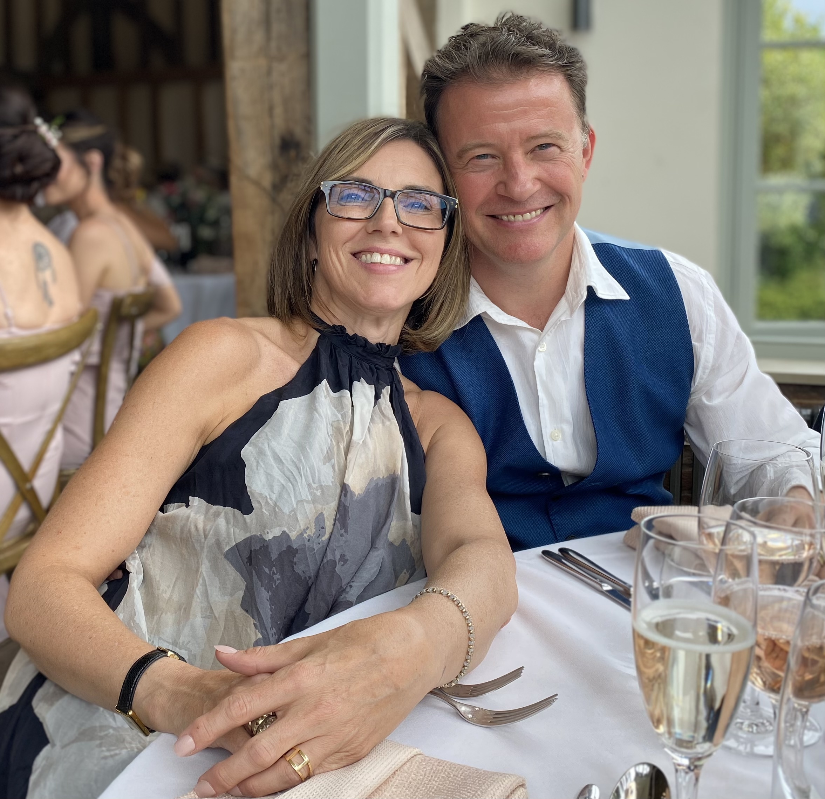

Oliver and Kathy have been married for 25 years next year. They have two boys, Thomas, 23 and Alex, 21.

Prior to moving to Ottershaw they had run a complementary health clinic in Surbiton for 18 years which they closed in 2019. The pandemic meant that they had to delay getting back to practising osteopathy until September last year. In the meantime Oliver began teaching at the osteopathy college from where he qualified and he continues to do this a couple of days a week.

Thomas recently graduated from university in Canada. He is currently working in London and applying for postgrad programmes. Alex is in his final year at university coming home occasionally ‘to get away from it all’

Otherwise life is spent in Ottershaw with occasional visits to Canada where Kathy hails from and still has a sizeable amount of family to visit. Oliver is local, having been born very close to Hampton Court though living in Ottershaw is the first time he has ventured outside the M25 to live, other than school and university.

Secondly Robin Green (4 The Old Orangery) Writes

Pretty much exactly 10 years ago I stumbled, literally, on 4 Old Orangery. I was looking at buying a flat in Tulk house as my little pied a terre, and decided to walk up the road, to my astonishment I fell upon the mansion and immediately fell in love. I promptly told the estate agent that the flat in Tulk house wouldn’t do and he arranged for me to visit 4 OO. Three months later I moved in.

How is it that I needed a pied a terre, you might be wondering? As the last of 4 children, whose father was English and mother was Belgian I grew up in both countries, so I speak English and French fluently and that has been very useful not only professionally but also for my private life, Caroline my wife is also from Belgium, coincidentally maybe, I’m not sure as we met here in London 34 years ago, and 3 weeks later I asked her to marry me. We lived very happily in Wimbledon and had 3 boys, just under 4 years apart. I was working in Esher, so would travel up and down the A3 everyday, it was always busy, and then going to Heathrow to catch a flight somewhere pretty much every week. I loved my job, which was running the European subsidiary of a Japanese company called Duplo.

My midlife crisis occurred exactly when I was 45, I convinced Caroline and the 3 boys we should move to Switzerland, I say convinced probably coerced and bribed is closer to the truth. I’d reached a point where the noise of the A3, we lived within earshot, had gotten too much and I was never actually in the office because I was travelling to Europe every week, so it didn’t really matter where I lived. Having worked as a student in Switzerland when I was 18, I’d secretly fallen in love with the place and just thought it would be a wonderful experience for the whole family. I said to the boys: "one thing I can guarantee is that you will go through change in your life, so we might as well practice all together".
So in August 2007 we moved to a little village called Prangins, between Geneva and Lausanne and a year later we found a wonderful plot of land a few miles away in a village called Gingins, where we now live in a house that we built. I continued to commute but this time back to London every week and that is why I needed a pied a terre.
4OO is brilliant: a beautiful location, with wonderful gardens, that I didn’t have to take care of. Very friendly neighbours and I could simply close the door, knowing it would be fine until I returned the following week. Covid struck, the Japanese decided to make a change and so at the ripe old age of 60, I'm now enjoying retirement and Caroline and I are wondering where we should live as we have one son working for Porsche in Germany, one working in IT in Melbourne, Australia, with no intention of coming back, and our youngest Henry working as a management consultant in London. South Africa, looks like somewhere in the middle!?

Projects at the Mansion

There remains a significant list of projects at the Mansion, which is perhaps not surprising given the age of our building and the extent of our grounds, which continue to require close attention, such as: structural issues, water ingress (roof leaks and others not helped by the significant rainfall over the winter), drainage, decoration, improvements and repair.

One of the biggest projects recently completed was the renovation of the private garden pond and fountain. It now looks superb and should last us many years to come (see photo below).

Projects for 2023 include: window repair and decoration; fire risk assessment, asbestos and electrical works; old orangery façade; and, roof repair.

The Mansion Projects Subcommittee meets on a frequent basis to assign tasks and responsibilities. The Subcommittee comprises: Scott Carey, Ben Townsend, Aya Hirai and Russell Jacobs. We are also incredibly well served by our Maintenance Officer, John McGowan, who works at the Mansion Wednesday-Friday.

The full list of projects can be found on the Mansion website, available at (www.ottershawparkmansion.com) and updates are provided at each Management
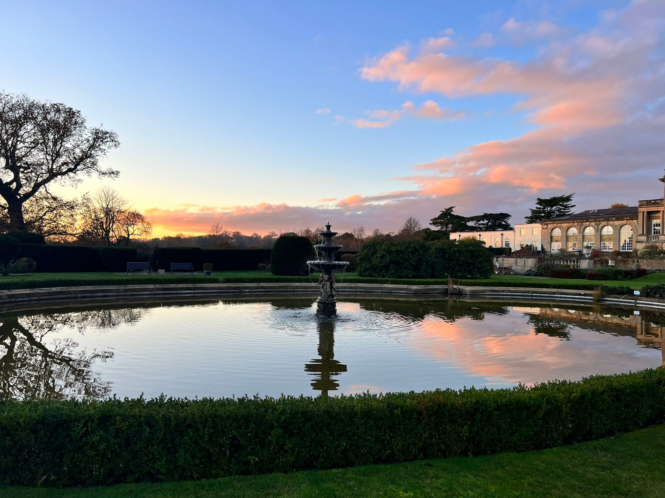

The Ottershaw Roundabout

Latest update 12 February 2023 from representatives of
- Ottershaw Neighbourhood Forum
- Ottershaw Brox Road Action Group
- Ottershaw Society
- Ottershaw & West Addlestone Residents Association
- Murray Road Residents Association

A great deal is currently on going in Ottershaw to combat the recent Surrey County Council (SCC) decision to proceed with the new Ottershaw roundabout traffic scheme. The current understanding is that it may now require a full re-submission of the SCC planning application.
In brief, the main reasons why: ·
- Failure to comply with the British standard for the Veteran Trees with hedgerows on Murray Road which is now a requirement of the planning conditions imposed by SCC; ·
- Significant changes to the solution resultant from the Compulsory Purchase/Side Roads Order for land granted by the Secretary of State which differs to the design granted by the SCC Planning Committee on 27 July 2022;

Ottershaw community groups and Neighbourhood Forum are continuing to work together to resolve these important issues with SCC on their design well in advance of any development work starting. The current design by SCC is seriously deficient in many areas which, if not addressed, will badly impact local residents and the environment particularly as this solution is heavily biased towards vehicle users. We are trying hard to engage with SCC to achieve the following: ·
- a significantly improved design in line with wishes for the new roundabout.
- ·an agreed plan to ensure the many traffic issues resulting from this development across the wider area are fully addressed. ·
- to ensure that the village is best protected now and in the foreseeable future.·
- to ensure traffic plans for diversions etc during the construction phase are suitable and appropriate.
The group are meeting with the local SCC councillor, Cllr. Jonathan Hulley very soon and, with support of the local MP, Dr. Ben Spencer, we hope that in light of the clear discrepancies and issues, they can pursue the improvements for our village with Surrey’s A320 HIF Scheme project team.
Fairoaks Airport

Flying operations seem to be the lesser of two evils to the majority of OPEC/Mansion residents. The uncertainty over the future of the airport site will not have helped the continuing airport operation. Last year Airport Development Partnership (ADP), the owners of the ‘built’ 40 acres (previously called the Major Developed Site) declined to renew Fairoaks Operations Ltd’s leases on the Control Tower, Fire Station and the hangar that they have occupied probably since they were built. The ‘airport’ was required to replace those facilities at short notice.

We would recommend that all residents refer to the airport’s website https://fairoaksairport.uk/
which is a source of useful information if you explore the menu and click on the links.

With careful searching you will find a link to the map of ‘Avoidance Areas’, which includes Ottershaw Park. Click on ‘Pilot Information/Noise Abatement/Avoidance areas.
https://fairoaksairport.uk/wp-content/uploads/2019/06/FAIROAKS-Avoid-Area-Map.pdf

As Ottershaw Park is an ‘Avoidance Zone’ for all air traffic, any complaints about inconsiderate flying practices or noise should be referred direct to the airport via their website, www.fairoaksairport.uk look for ‘noise complaints’ under ‘local residents’ in the menu bar.
Home, Ottershaw East, Brox Road Action Group (ottershawbrag.com)
Fairoaks Airport (@fairoaksairportuk) • Instagram photos and videos
Welcome - Fairoaks Airport

The planning application with respect to Fairoaks Village was withdrawn and as of today (2 March) no further application had been made to Surrey Heath Council.

There have been no posts about the furtherance of a Fairoaks village in the 3 months so we suppose that no news is good news!

Road Closure
The main entrance road will be resurfaced on 24-25th April. On the
first day there may be delays, but on the second morning the road will
be CLOSED.
An alternative route via the Bothy Lane and under the bridge will be
available but is not suitable for large vehicles.
Please avoid vehicle movements on the morning of 25th April if possible.
In anticipation of this event two bollards on the Bothy side of the
bridge have been removed and a temporary plastic barrier erected in
their place. The bollards will be replaced in a manner that will permit
them being removed more easily in the future if required.
Mansion Management Committee

The Management Committee serves the interests of all residents and meets regularly to agree budgets, work plans and responsibilities, which are then rubber-stamped by all residents, as appropriate. The Committee members are:

- Russell Jacobs – Chairman
- Peter Bennett – Member
- Scott Carey – Projects
- Ben Townsend – Communications & Leisure Facilities and general factotum
- Mary Turner – Gardens
- Graham Hughes – OPEC Liaison, property transaction reporting and Newsletter editor
- Paul Featherstone – Web master
- William Van Klaveren – Insurance Matters
- Aya Hirai –Treasurer
- James Oxley – Fire safety guru

Almost half of all households at the Mansion are now on the MC, which is great news and a testament to the community spirit we enjoy, even if passionate views are expressed from time-to-time!

Special recognition should also continue to go to Neil and Marion Drummond (West Wing, No. 23) who support the MC, and all residents, with the Mansion accounts. Neil is an invaluable member of the team.

Forthcoming Mansion meetings

- OPM MANAGEMENT Committee Meeting 21 March 2023 18:00
- OPEC MANAGEMENT Committee Meeting 18 April 2023 1900

Communications at the Mansion

Residents receive regular updates and notices, such as Residents’ meetings and AGM minutes, via email from the Management Committee team, including the Chairman (Russell Jacobs), and the Communications Officer (Ben Townsend).

A number of WhatsApp groups have also been created in order to circulate important and targeted Mansion news quickly and efficiently. If you are not on the main WhatsApp group and would like to be, please ask Ben directly. For those not on the group and would prefer to keep it that way, please fear not! You will still receive all updates as normal, via email.

There is also quite a large WhatsApp group for KT16 0QG which disseminates news about the whole estate. Ali Roche is the administrator along with Mick. Contact 07775 591522 or by email at alisonroche@btinternet.com.

Parting shots

Photos by Graham Hughes

